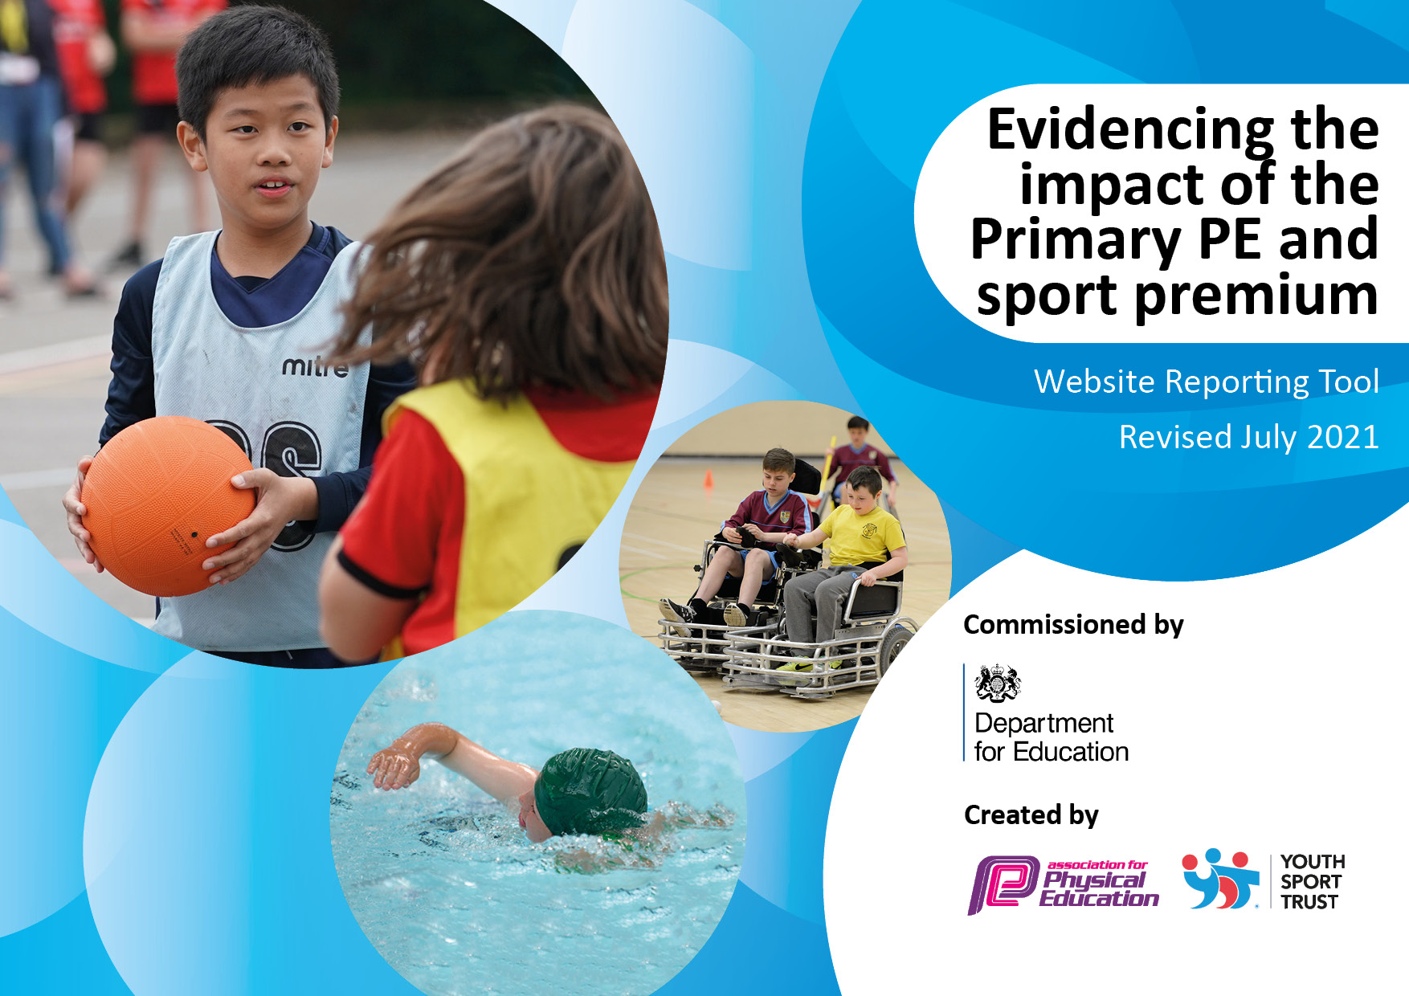
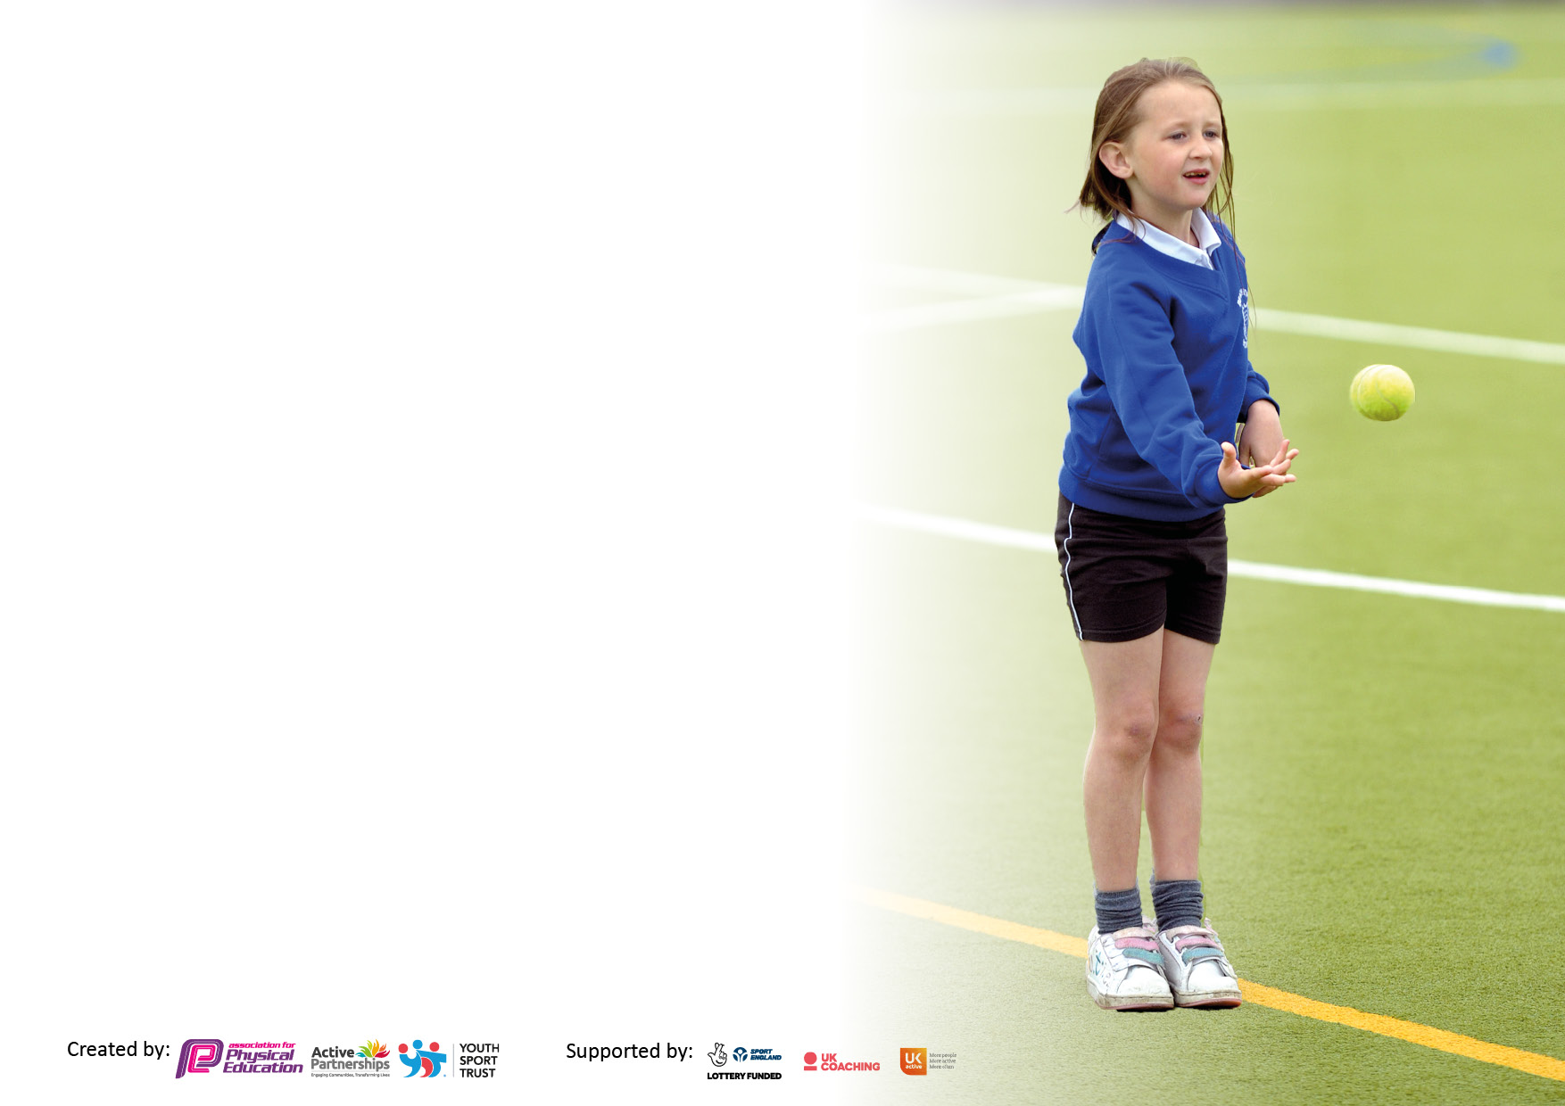

It is important that your grant is used effectively and based on school need. The Education Inspection Framework makes clear there will be a focus on ‘whether leaders and those responsible for governors all understand their respective roles and perform these in a way that enhances the effectiveness of the school’.

Under the Quality of Education Ofsted inspectors consider:
Intent - Curriculum design, coverage and appropriateness
Implementation - Curriculum delivery, Teaching (pedagogy) and Assessment
Impact - Attainment and progress

To assist schools with common transferable language this template has been developed to utilise the same three headings which should make your plans easily transferable between working documents.

Schools must use the funding to make additional and sustainable improvements to the quality of Physical Education, School Sport and Physical Activity (PESSPA) they offer. This means that you should use the Primary PE and sport premium to:

- Develop or add to the PESSPA activities that your school already offer
- Build capacity and capability within the school to ensure that improvements made now will benefit pupils joining the school in future years
- The Primary PE and sport premium should not be used to fund capital spend projects; the school’s budget should fund these.

Pleasevisitgov.ukfortherevisedDfEguidanceincludingthe5keyindicatorsacrosswhichschoolsshoulddemonstrate animprovement.Thisdocumentwillhelpyoutoreviewyourprovisionandtoreportyourspend.DfEencouragesschools to use this template as an effective way of meeting the reporting requirements of the Primary PE and sport premium.

We recommend you start by reflecting on the impact of current provision and reviewing the previous spend.

Schools are required to publish details of how they spend this funding, including any under-spend from 2019/2020, as well as on the impact it has on pupils’ PE and sport participation and attainment. All funding must be spent by 31st July 2022.

We recommend regularly updating the table and publishing it on your website throughout the year. This evidences your ongoing self-evaluation of how you are using the funding to secure maximum, sustainable impact. Final copy must be posted on your website by the end of the academic year and no later than the 31st July 2021. To see an example of how to complete the table please click HERE.

Details with regard to funding
Please complete the table below.

Total amount carried over from 2019/20 | £9155
Total amount allocated for 2021/22 | £16,590
Total amount of funding for 2021/22. To be spent and reported on by 31st July 2022. | £25,745
Swimming Data
Please report on your Swimming Data below.

Meeting national curriculum requirements for swimming and water safety.  N.B. Complete this section to your best ability. For example you might have practised safe self-rescue techniques on dry land which you can then transfer to the pool when school swimming restarts.  Due to exceptional circumstances priority should be given to ensuring that pupils can perform safe self rescue even if they do not fully meet the first two requirements of the NC programme of study | 100%
What percentage of your current Year 6 cohort swim competently, confidently and proficiently over a distance of at least 25 metres?  N.B. Even though your pupils may swim in another year please report on their attainment on leaving primary school at the end of the summer term 2020.Please see note above | 100 %
What percentage of your current Year 6 cohort use a range of strokes effectively [for example, front crawl, backstroke and breaststroke]?  Please see note above | 100%
What percentage of your current Year 6 cohort perform safe self-rescue in different water-based situations? | 100%
Schools can choose to use the Primary PE and sport premium to provide additional provision for swimming but this must be for activity over and above the national curriculum requirements. Have you used it in this way? | Yes/No

Action Plan and Budget Tracking
Capture your intended annual spend against the 5 key indicators. Clarify the success criteria and evidence of impact that you intend to measure to evaluate for pupils today and for the future.

Academic Year: 2021/22 | Total fund allocated:£25,475 | Date Updated: July 2022
Key indicator 1: The engagement of all pupils in regular physical activity – Chief Medical Officers guidelines recommend that primary school pupils undertake at least 30 minutes of physical activity a day in school |  |  |  | Percentage of total allocation:
 |  |  |  | 2.8%
Intent | Implementation |  | Impact | £729.26
Your school focus should be clear what you want the pupils to know and be able to do and about  what they need to learn and to  consolidate through practice: | Make sure your actions to achieve are linked to your intentions: | Funding allocated: | Evidence of impact: what do pupils now know and what can they now do? What has changed?: | Sustainability and suggested next steps:
Children to be able to participate in gymnastic and net and wall games using the appropriate equipment. Children to build positive relationships through teamwork and games  To inspire more children to become physically active | New benches purchased for gymnastics and balls to be used for dodgeball lessons and after school clubs.  Tag rugby belts purchased to be used across the whole school.  Sports for Schools Athlete event. Jenny Wallwork carried out a sponsored fitness circuit with the whole school. | £676.81  £52.45  No cost | Children benefit from using equipment appropriate for the activity. Children are able to participate in after school clubs.  Children say they were inspired to listen to Jenny’s career and how she got into badminton. Pupil Voice: ‘I’d like to try badminton out of school’  ‘ I’m going to ask my mum if I can play badminton’ | - Look at more gymnastics equipment for the next academic year. Audit all PE equipment and replace any damaged equipment.  Opportunity to look into a racket sport after school club.
Key indicator 2: The profile of PESSPA being raised across the school as a tool for whole school improvement |  |  |  | Percentage of total allocation:
 |  |  |  | 6.2%
Intent | Implementation |  | Impact | 1612.54
Your school focus should be clear what you want the pupils to know and be able to do and about  what they need to learn and to  consolidate through practice: | Make sure your actions to achieve are linked to your intentions: | Funding allocated: | Evidence of impact: what do pupils now know and what can they now do? What has changed?: | Sustainability and suggested next steps:
Subject leader to ensure they are up to date with current policies and practices in PESSPA. To share good practice with other PE subject leaders across Harrogate and have access to new ideas. To gain access to different sport competitions and to hear about other competitions taking place across Harrogate. | Talk to other PE subject leaders from across Harrogate and share good practice and ideas). To liaise with Harrogate High School Sport Partnership regularly. Support with the PE page of the school website. | £1400  £212.54  X2 days Subject Leader course HHSSP | This year, the partnership has been a vital tool to ensure networking and sharing PESSPA ideas could be maintained.  As a new PE subject leader, they have provided support including:  *national updates  *school games | If we are to use the partnership next year. Ensure we are making use of all the support available to us. Including sports competitions??

Key indicator 3: Increased confidence, knowledge and skills of all staff in teaching PE and sport |  |  |  | Percentage of total allocation:
 |  |  |  | 65%
Intent | Implementation |  | Impact | £16,786.85
Your school focus should be clear | Make sure your actions to | Funding | Evidence of impact: what do | Sustainability and suggested
what you want the pupils to know | achieve are linked to your | allocated: | pupils now know and what | next steps:
and be able to do and about | intentions: |  | can they now do? What has
what they need to learn and to |  |  | changed?:
consolidate through practice:
Helping support every child to develop the physical literacy, emotional and thinking skills to achieve in PE, Sport and life.  Prepare staff to teach Real PE again from September 2022.  Ensure that all children access a broad balanced and progressive curriculum. Staff to observe good practice to support them in their own delivery. | Real PE Jasmine Online Platform licence for the academic year  REAL PE refresher training. Pam Stevenson carried out a refresher training session during staff meeting time.  Sporting Influence Coaches contract. SI staff delivered PE lessons across the school. | £ 500  £163.50  Term 1  £2476.67  £2476.67  Term 2  £2716.67  £2716.67  Term 3  £2476.67  £3260.00 | All children & staff accessing a simple, efficient and progressive learning platform with clear next steps and clear learning outcomes.  Children have a clearer understanding of how to succeed through watching, coaching and assessing their peers.  All staff have a clearer understanding to the intent of REAL PE. Staff understand the Learning Focus and know how to implement the ‘cogs’ and Fundamental skills in their lessons.  All children enjoy and progress well in their PE lessons. Children feel well supported and appropriately challenged.  Pupil voice:  Staff receive regular CPD opportunities each term. The observe, team teach and deliver PE lessons. | From next year:  - Staff to use the Jasmine online platform in all Real PE lessons. Children and staff to get used to watching the videos and discussing the SC throughout lessons.  - Subject leader to monitor the use of REAL PE.  - Staff to ensure they are using the Learning Focus ‘cogs’ as an integral part of their teaching of the Fundamental Skills  - Begin to use the assessment wheels once staff have become confident in teaching using the platform.  - Continue to use the partnership and CPD opportunities next year.  - Explore Assessment opportunities.
Key indicator 4: Broader experience of a range of sports and activities offered to all pupils |  |  |  | Percentage of total allocation:
 |  |  |  | 4%
Intent | Implementation |  | Impact | £1025
Your school focus should be clear | Make sure your actions to | Funding | Evidence of impact: what do | Sustainability and suggested
what you want the pupils to know | achieve are linked to your | allocated: | pupils now know and what | next steps:
and be able to do and about | intentions: |  | can they now do? What has
what they need to learn and to |  |  | changed?:
consolidate through practice:
Participation in variety of Sporting Influence competitions across the school.  Class 5/6 experience to attend an international stadium- Yorkshire Cricket at Headingley stadium.  Provide children with the opportunity to learn the life long skills needed to cycle on the roads safely. | Signed up to attend the Sporting influence competitions.  Transport mainly provided by staff.  Autumn- Football  Spring- Tchouckball & Dodgeball  Summer-Cricket  Pay for the class to attend the workshops and take part in a game of kwik cricket at Headingley Stadium.  Provide a coach for the children to attend the trip.  Bike ability sessions for year 6 children. | £400  £210  £175  £240 | The children had a fantastic time attending the competitions. They enjoyed playing as part of team and representing the school.  The children were able to implement the skills they had learnt in their PE lessons to a competitive context.  The children had a fantastic day. The enjoyed the experience of visiting an international stadium. Some children commented that they would like to try cricket in their local area.  All children completed the course successfully and felt they understood how to be safe on the roads today when using their bike. | Look at alternative options to travel to the competitions.  - Using coaches  - Ask parents to help  Continue to offer the children these kinds of opportunities next year.  Continue to offer this opportunity to the year 6 children next year.

Key indicator 5: Increased participation in competitive sport |  |  |  | Percentage of total allocation:
 |  |  |  | 1.5%
Intent | Implementation |  | Impact | £400
Your school focus should be clear | Make sure your actions to | Funding | Evidence of impact: what do | Sustainability and suggested
what you want the pupils to know | achieve are linked to your | allocated: | pupils now know and what | next steps:
and be able to do and about | intentions: |  | can they now do? What has
what they need to learn and to |  |  | changed?:
consolidate through practice:
Participation in Sporting Influence competitions across the school. | Signed up to attend the Sporting influence competitions.  Transport mainly provided by staff.  Autumn- Football  Spring- Tchouckball & Dodgeball  Summer-Cricket | £400 entry fee for the year. | The children had a fantastic time attending the competitions. They enjoyed playing as part of team and representing the school.  The children were able to implement the skills they had learnt in their PE lessons to a competitive context. | Look at alternative options to travel to the competitions.  - Using coaches  - Ask parents to help

Signed off by
Head Teacher:
Date:
Subject Leader:
Date:
Governor:
Date:

